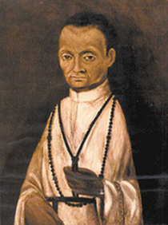

**Sacred Heart Cathedral – St. Martin de Porres Society**

**Black History Month 2021 – Essay Contest**

Students are asked to select a Black historical figure, and demonstrate through a minimum 500 word essay, the importance of the contributions and impact that this individual had on Black History as well as society in general.

Essays will be judged as follows:

* Uses Student’s Own Voice
* Did the essay demonstrate the individual’s contribution to or impact on Black History & society in general?
* Does the essay contain sufficient information on the subject?
* Originality, Writing Style, Grammar and meeting the minimum expectation of length will also be considered.

Essays should be submitted via email (as an attached Word document) to [St.Martin@assumptionhigh.org](mailto:St.Martin@assumptionhigh.org) on or before 11:59pm on Sunday, March 7, 2021. Winners will be announced by March 22, 2021.

All students in grades 9-12 are eligible to participate. A $50 gift card will be awarded for 1st Place, $30 gift card for 2nd Place and $20 gift card for 3rd Place.